 Christ Church C of E VC Infant School
Standards & Curriculum Committee
Caring Governors, Courageously Challenging, Inspiring All
Minutes of meeting held on 12th November 2021 @ 9.05am via Teams
Committee Members: Anna Martin, Gareth Jones, Amelia Gould, Charlotte Munday (Vice Chair), Jenny Sheppard, Robin Butcher (Chair), Julie Wilkins.
Clerk: Laura Jones
14/20 Welcome and Apologies

Welcomed everyone to the meeting.

Apologies: Jenny Sheppard (received in advance of the meeting)

15/20 Declaration of Pecuniary Interests
None
16/20 Minutes of the last meeting
Minutes signed off.
17/20 Governors Actions and Commitments
There was nothing from the school improvement plan. Reviewed it last week with SLT and we have nothing outstanding.
18/20 Governor Monitoring
Lot of monitoring going on in school, but nothing for governors to do this term, something for FS&P – to be discussed in that committee.
19/20 Heads Report
Priorities are to improve our maths outcomes for PP children. Pictures shown to make it visual. About mastering numbers and to try and stop children counting on their fingers as it stops them solving the problem and take longer to calculate a problem. Giving all children the skills to work things out quickly and gaining confidence in PP children. Reviewed in staff meeting last week how successful. Lots were saying children are applying it in their learning.
Focus talk for writing and saw that being used well particularly in EYFS and Y1.
Given children the story language to be able to then write, otherwise hard for them to tell a story. They draw out the whole story and then they retell it repeatedly, then they can really tell a story and it’s effective.
Pupil progress meeting showed how well the staff know their children. More parents are now seeing the impact of Covid on their children. More children being a bit reluctant to come into school and not being able to regulate their anger due to less time socialising. Children have lower levels of resilience as less time in preschool and school where they learn those skills.
Big focus on ELSA, the emotional literacy training which give children skills to cope with anxiety. Picture shown of the zones of regulation, how children are helped to regulate their anger. The school will help to support parents with workshops and come together in a group to support one another which is invitational.
JW: How easy is that to fit in amongst everything else on everyone’s plate, regarding the daily physical exercise?
Doing bits already and as a brain break if the class is lively or stops engaging. We get them outside, good strategy and something the teachers should be doing otherwise children can’t access the learning and good to keep their fitness up (affected by covid). Teachers join in and encourage the children. Go Noodle or YouTube in the classroom and then dancing to three different songs is effective.
RB: Question regarding ELSA. It is going to be focussed more on EYFS because of not having the ability to break from their parents or are you seeing it across the all the years?
Probably more Y1 and Y2 as it’s more natural for EYFS to not want to be separated from their parents, but it’s also looking at are they too anxious to access the learning and how can we help them with those sorts of situations to grow in confidence and be able to manage stressful situations.
CM: Have we got the resources if this does show up that there's more children than we know about? Can we tackle it?
SENCO is prioritising. Something else will have to go. Labour intensive but be worth it. Won't have time to do it for everyone that needs it, so it will be prioritising the children that need it most.
Target document shared with Governors. All targets are aspirational. Because of Covid and just into T1 we were hit before half term with low staff numbers, lots of staff change, inconsistent teaching and lots of children out. Not inflating targets. They are realistic but also aspirational.
JW: You're saying it's not stretching target, but would you be pleased if we hit that? Because writing has been such a challenge, it feels like it's it would still be a good achievement.
Yes, and there were a few children that we had to push up. In PP children we wanted to see greater depth for them in certain subjects, and to ensure teachers aim high.
Our challenge support partner and a member from the EYFS LA Team visited. Determined what level of support school needs from the LA. The LA are allocating an LA Advisor and given an EYFS Advisor. Corroborated our judgements and seen massive progress in the Early Years provision outside and internally.
Highest category and don’t need support. Quality of teaching across the school good and felt that the provision was superb. Progress in books was excellent. The behaviour was outstandingly good. Children are liked by their staff, and they know that, and so they want to engage. Lots of practical and outdoor learning across the school. Children were able to say what they were learning and why and engaging with the states of being.
Pupil conferencing occurred with some very articulate children. When children were asked why they need to be good at maths, none could answer so this is something we need to work on, so they understand why they are learning what they are.
Also had feedback that the Governance of the school is strong, able to articulate finance, curriculum and safeguarding clearly. Well informed but also challenging
RB: Fantastic to hear. Do they follow up in writing or is that literally the meeting and that's it? If something is written could that be shared?
Visit note will be written. Usually shared with the Chair of Governors but happy to share with Governors if it isn’t confidential.
RB: Regarding the LA advisor, you said it was great to have EYFS as a focus. Was there anything specific that you felt worked well, or was there anything that specifically you gained from that?
Pleased to hear it said if you don’t get children to sit on the carpet and use the whiteboard now, they will struggle to learn it and good to have high expectations of the children. There was good advice about what we do for children who aren't ready to write yet using message centre which will be explored to help children record their communication through symbols and messages.
RB: It sounds like the message centre is something like ELSA so could be some interesting overlaps there.

20/20 SEN & PP
Various numbers of PP and SEN children across the year groups. Numbers could increase due to further children being added to the SEN register. Strengths discussed, such as differentiation and provision for SEN and PP children and being able to see this in the books. Children engaging with their learning independently. Mastering numbers has been successful.
The Enquiry curriculum has been amazing for those children and has enabled them to really access it and given them different experiences. SENCO brought in enrichment activities i.e., cooking or going to shop to buy ingredients. To be done termly. Language and writing have improved. Priorities are language development – vocabulary acquisition, ensuring SEN support matches provision, and zone of regulation.
JW: How does the support plan get communicated between SENCO and class?
SENCO looks at these termly and reviews with the parents. SENCO checks the interventions are in place and offers extra support and guidance and can train staff.
JW: Sounds like it’s good co-working between SENCO and the relevant teaching staff.
SEN paperwork big stressor for staff but vital it is up to date. SEN parents may be contacted by Ofsted, so they need to know what is in the support plans.
RB: Indicated numbers may increase. What are the implications for the individual and the teaching staff such as funding and capacity to support?
If added to SEN register and there’s a barrier to the child making progress, different strategies will be implemented to support that child. They will have a plan which states what their needs are and what the strategies are which are shared with parents. We monitor closely, if a strategy doesn’t work, we’ll try something else and assess the situation. ELSA and zones of regulation will help. Level to get SEN funding is high. Use of Boxall assessment which shows a child’s area of need which will then give strategies and targets.

21/20 Deputy Head Report
*Screen shared to show school website. *
Hoping to get website redevelopment done for half the price.
Important as Governors to understand the vision and values of the school.
Discussed the overview page of the curriculum. Curriculum is based around the vision and values.
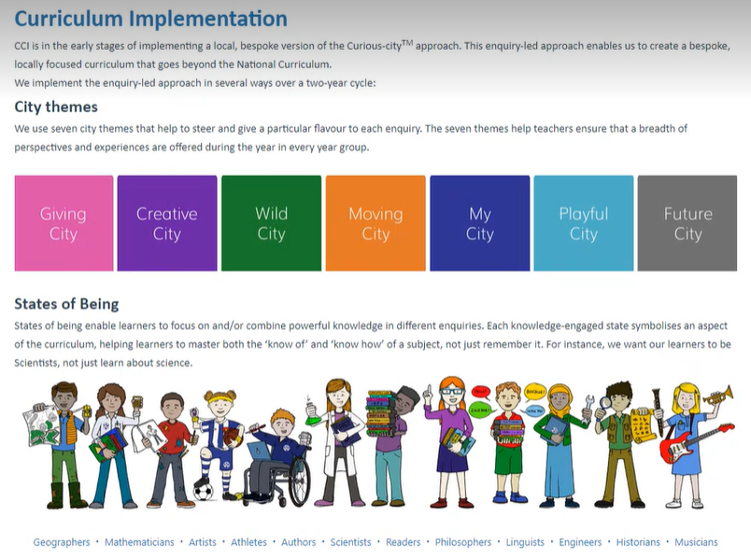
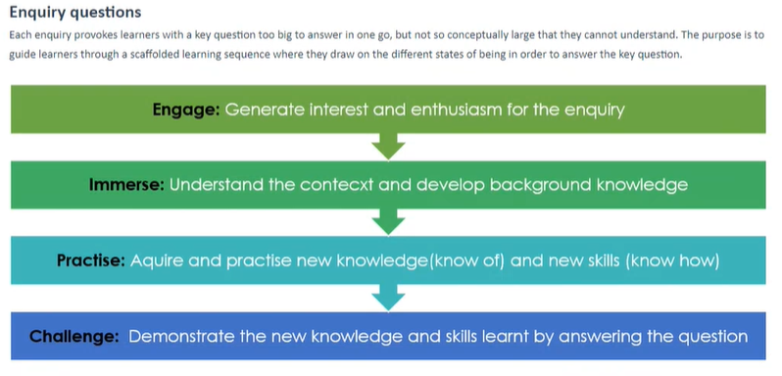
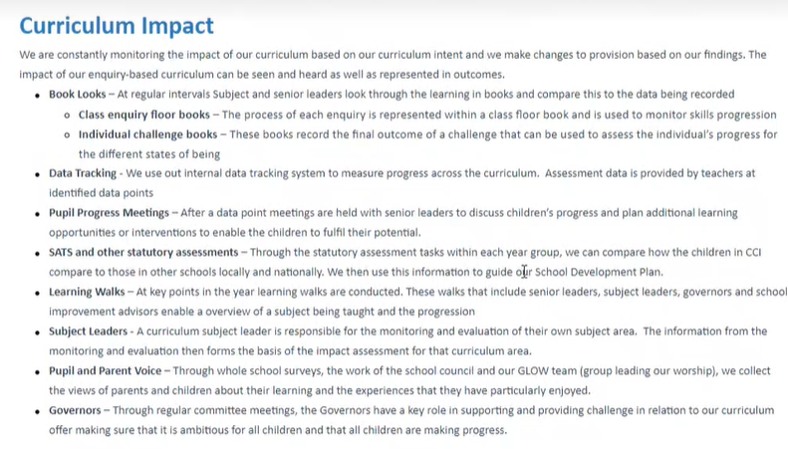
JW: What is a floor book?
Like a scrap book where you can insert pictures of things, post it notes and statements that the children have made. A bit of a mish mash of information. Key is getting the children’s comments.
Talked about the states of being.
Below shows how phonics are taught:
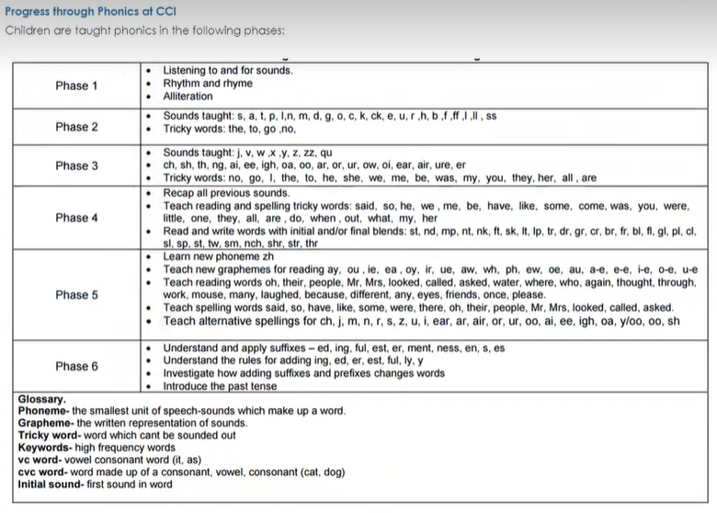
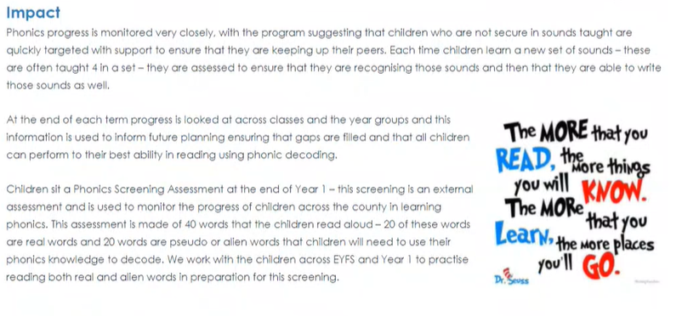
Below shows how maths is prepared for:
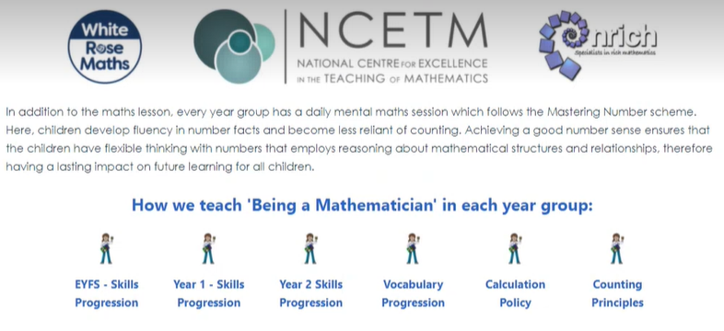

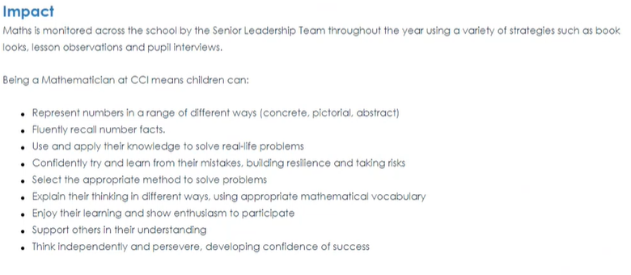
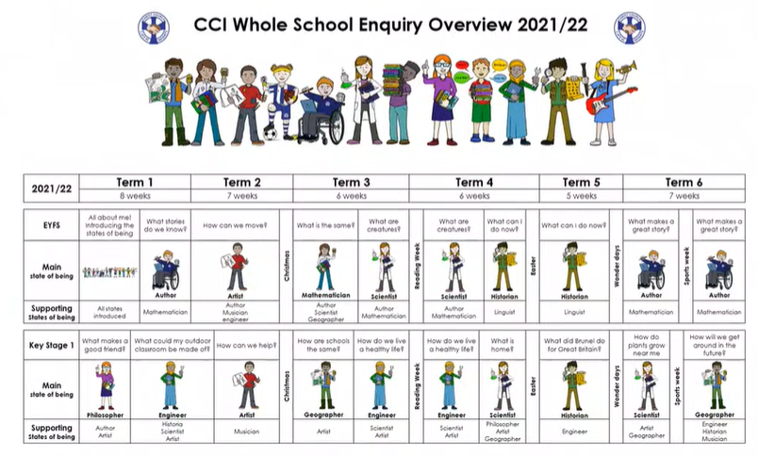
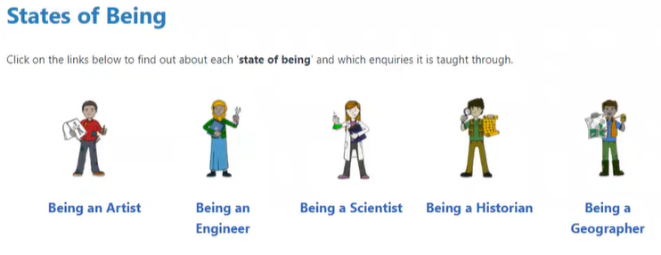

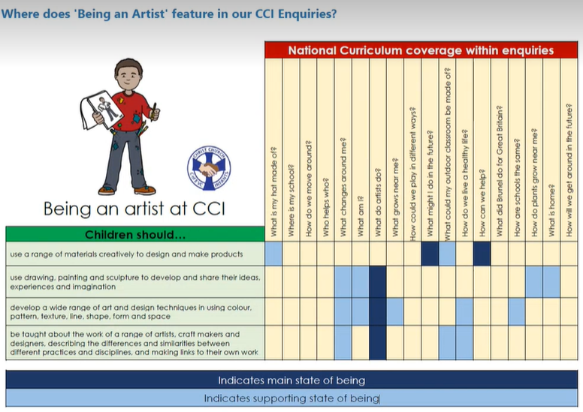
JW: Acknowledged how much work has gone into the website. Lots of information which is of value to all Governors. Is there a timeline for deciding who the leads will be for all subjects?
Need to be done asap. Teachers to look at what needs to be done with DH supporting with any questions or concerns.
JW: Suggested a timetable of when the school want the areas to be done by but shows realistic timescales which will take away some of the stress and help with wellbeing.
Agreed this is a good idea to have a rolling programme and to have a plan in place.
JW: How much more money do we need for the website if this can’t be done at half price?
Roughly £800 but hoping to get it cheaper.
RB: Acknowledged how much work has gone into the website and how great it is. How do we ensure we are pointing people to the right parts of it, for current parents? Would it be of value to have a working group to review content and what is useful?
We have that in hand with another Governor who is also a parent. There is a parent area but talked about Ofsted focussed areas. Will simplify the parents’ area so it’s easy to follow and useful.
22/20 Policy Review
No policies due for review
23/20 AOB
None
24/20 Date of Next meeting:

28.01.22 @ 09:05am

Meeting closed @ 10:20am

