Christ Church C of E VC Infant School
Finance, Staffing & Premises Committee
Caring Governors, Courageously Challenging, Inspiring All
Minutes of meeting on 21.01.22 @ 9.05am via Teams
Committee: Jacky Wood, John O’Driscoll, Anna Martin, Jenny Falco (Vice Chair), Chris Douglas (Chair)
School Business Manager: Cath Evans

Clerk: Laura Jones
27. Welcome & Apologies:  Chair welcomed everyone to the meeting.  Topic for the term is Courage. Discussed Mohammed Ali’s famous quote “he who is not courageous enough to take risks will accomplish nothing in life. Sums up how the school has been, particularly over the last few months with the new curriculum and Covid, making courageous decisions. It’s a great topic to start the New Year with. | Actions
28. Declaration of Pecuniary and Business Interests

None declared.

29. Approval of Minutes

Minutes were approved from the last committee meeting

30. Late Items

A few items for Governors to be updated on within the Head / SBM section, which have come to light since the agenda was circulated.

31. Review Actions Log  FS&P Action Log reviewed and discussed. Wellbeing Governor talked about having different representatives within the wellbeing meetings. Wellbeing survey was circulated to Governors straight after the committee meeting and the lettings policy was added to this meetings agenda for further discussion. All current open actions have been discussed and dealt with so can be called as closed. | Clerk to update open actions to closed.
32. Head / SBM Report

Free school meals and PP numbers have not changed. Census day numbers were average yesterday.

Regarding the school budget, a monitoring meeting occurred this week and the outcome was good, we have managed to save a bit more money. We have savings in computer equipment, although a couple of staff need new laptops. Hopeful by the end of the school year we’ll be able to claw a bit more back.

More funding coming in for EHCP’s which haven’t yet been listed on this review because it’s not yet set in stone. Will be spent on staff apprentices, which is in the budget and planned for.

Quite a lot of staff sickness now and trying to fill in house where we can. A few cases are going through the insurance and waiting for the outcome.

ACTION 21.01.22 01 Snapshot to be sent to Governors from the budget monitoring meeting.

Audit which happened in 2019 had a few action points to go over. Lots of policies have been sorted and more forthcoming to be approved by Governors at future committee meetings. We managed to get all the information back despite the Ransomware attack.

SBM had a meeting with another SBM from Blackhorse who helped give tips with how to streamline the look of the school fund spreadsheet and work out what we can spend which has been helpful and will be a great person to have on board. It should also mean we’ll have more money to spend on the playground which will be brilliant.
We also have quite a lot of lettings money coming in now which is fantastic and making the school look lovely ready for Ofsted.

We currently have about half the amount of money needed to start phase 1 of the school playground. If we have enough money in the school fund, we should hopefully be able to start phase 1 by Easter. It seems a long way of and a lot of money, but it is achievable.

We also have a meeting with the friends planned to discuss further actions and fundraising ideas.

Benchmarking Report:

The most comparative school on the benchmarking report was a junior school, but a junior school would have less staff and different ratios to an infant school because of the children being older, so bear in mind it is not like for like. Although our staffing is showing as quite high some of that is because we have employed three apprentice TAs, but that’s been worth it as even due to Covid we haven’t had any problems staffing classes. I wouldn’t look to reducing staffing as can cover with quality teaching.

Large out going on meals but because we have free school dinners for infants whereas that’s not the case in a junior school.

Governor: Main thing which stood out for me is we have quite a low premises total compared to a lot of schools, and we might be underspending in terms of our ground maintenance. In terms of occupancy costs, we were quite high on our energy bills.

This was discussed at the hub meeting yesterday and depending on what schools you have been benchmarked against you could come up with all sorts of different answers. Energy will be higher for us because of the swimming pool. We probably do spend less on premises because we aware we spend more on staffing

Governor: When it comes to energy suppliers, can we decide within the school, the hub, or does the council decide? How does that process work?

The council are set providers although that may change in the future.

Governor: So, it’s out of our control the energy bills, other than perhaps just not using as much?

We have got the heating on more now due to having all the windows and doors open, to ventilate the classrooms due to covid. It must be comfortable for the staff and children.

In terms of finance, during a recent Alliance Board meeting it was said the Government would like all schools to Academize or become Multi Agency Trusts, which would also mean stripping back the funding for school improvement. It doesn’t benefit schools in the hub as we are all good schools, and we have a duty that education in South Glos is well supported. LA have suggested schools pay money per pupil to put that money back into the hub so the services can continue. All schools agreed this would be a good idea and will look to implement that model next year. After that the funding will completely go so, we are considering all schools in the Alliance form a multi-agency trust together and get in our own school improvement advisors and don’t lose our autonomy. We will speak to other MATs to see how they work and what the process would be. This will also be extra money we need to add to the budget which has not yet been accounted for.

Governor: Why do certain schools have such a healthy budget in comparison to ours? Are we clear on the causes of why some schools struggle to recruit staff? Is it due to where they are based or the small class sizes?

One school has masses of funding because they are a primary school and because they have a large amount of PP children and due to the area they are in. You also get more funding for a junior school than an infant school. Budgets are poor in other schools due to them being in a rural area as well as class numbers falling.

Regarding safeguarding one thing which will be changed is our signage in the main entrance. The documents have been done they just need to be displayed. Specific peer on peer abuse training has also been trained out to staff. All safeguarding will be updated on the website.

We had a health and safety compliance questionnaire which was useful as it triggered us to put more policies in place and making sure various systems were in place. It will be a standing feature for us every year to ensure we comply with the checklist.

Chased LA to see what is happening with the Elliott buildings. This has been delayed due to a further request to tarmac around the outside as an extra which wasn’t what they agreed to initially. We think they will do it, but someone needs to come back out to requote.

Staff wellbeing seems good and a couple of monitoring things coming up which makes sure everyone is up to scratch. We have been told we are in the window of Ofsted. Staff meeting undertaken and Ofsted prep discussed. A few tweaks and tidy ups are being done.

Governor: When can we start charging lettings for the pool again?

This won’t be until Easter. It was a reduced fee for some time, and there are 87 hours left. Premier have asked for use of the swimming pool in half term.

33. Chairs Section:

To be discussed in the safeguarding update.

34. Policy

Lettings Policy and Lettings fees – SBM has made changes to the policy as discussed with Governors and recirculated to Governors. This policy has now been approved on 09/02/2022

Health & Safety Policy - SBM has made changes to the policy as discussed with Governors and recirculated to Governors. This policy has now been approved on 09/02/2022

Security Policy – Approved by Governors on 09/02/2022

Infection Control Policy - SBM has made changes to the policy as discussed with Governors and recirculated to Governors. Approved by Governors on 09/02/2022.

35. Safeguarding / Online Safety Update

Safeguarding Governor came into the school last term to do an audit. Went through the central record with SBM and raised several actions on the back of that most of which I believe have already been done. We had a run though of some of the policies which led to things like signage being updated. We also did some pupil conferencing which was very positive and interesting. Another visit will happen next term. Online safety policy will also be looked at being implemented more in school.

36. Health and Safety Update

Health and Safety Governor recently came into school. Action Log has been created by Governor as per the below with recommendations of improvements:

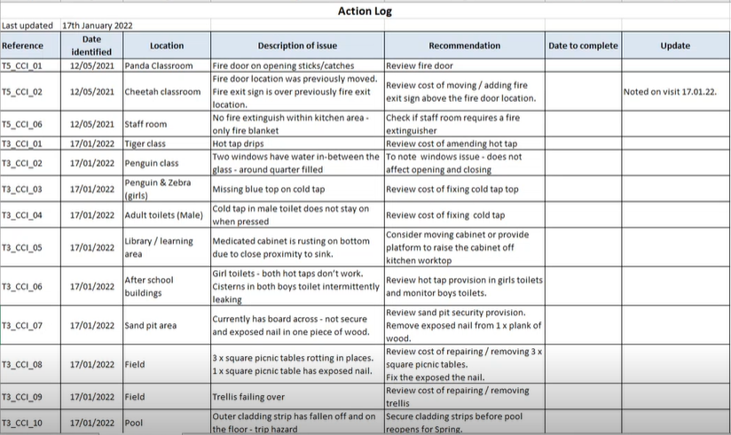

Assessment to be done and priorities to be given to each action / recommendation due to importance and budget.

ACTION 21.01.22 02: Follow up at the next committee meeting the actions on the health and safety log. Clerk to add to the FS&P action log and add to the agenda of the next FS&P meeting.

37. Forthcoming Events

SFVS

38. AOB

JO confirmed they may be unable to attend the next FS&P committee meeting. Advised to send any questions to the clerk prior to the next meeting to raise should need be.

39. Date of Next Meeting:

18.03.22 @ 09:05am via Teams
40. Meeting closed @ 09:58

