Behaviour Policy 2026-27
“Visible consistency with visible kindness allows exceptional behaviour to flourish.” Paul Dix

As a church school, the fundamental principles behind our approaches to behaviour are those of reflection, forgiveness, reconciliation and love towards all members of the school community. These sit within our church school values of friendship, compassion, courage, perseverance, thankfulness and respect. Each child is part of our school community and it is each individual's responsibility to make it a place where everyone is able learn and grow in a safe, inclusive, trusting and supportive environment. We strive to work collaboratively with children, staff and parents, keeping the child at the centre of our approach. This policy aims to set out the agreed approach to celebrating positive behaviour and procedures for dealing with negative behaviour.
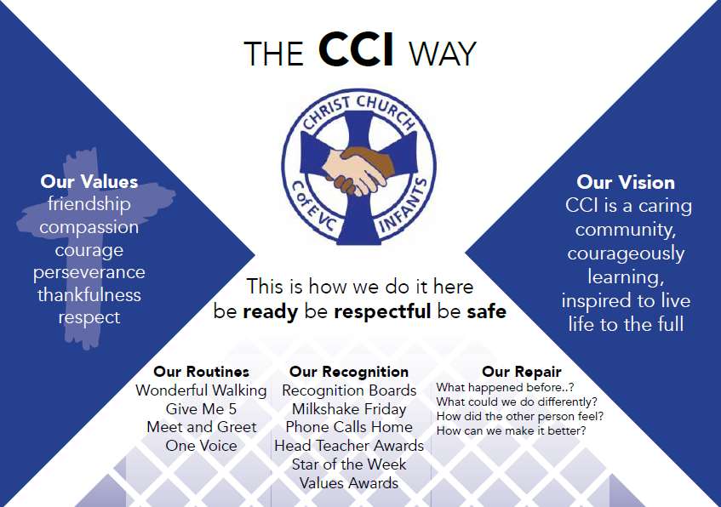

Signed CoG:  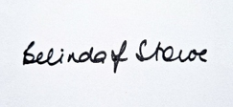 | Name: Belinda Stowe | Review Date: 14.9.26
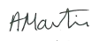  Signed Head: | Name: Anna Martin | Review: T1 2027-28
Behaviour Policy 2026-27

Intent
- To create a safe, productive and harmonious environment focussed on learning and positive, respectful relationships.
- To enable pupils to see the necessity of having established, fair rules and procedures that are intended to promote a positive ethos and culture in school to benefit the whole school community.
- To enable each individual to realise that his or her behaviour has a direct effect upon other individuals.
- To encourage pupils to understand and accept that people are different but interdependent and to develop a respect for all, regardless of background.
- To enable each pupil to reflect on their choices and the impact of them in order to support them in making better choices in the future.
- To give every pupil the opportunity to make a fresh start after an incident of negative behaviour.
- To develop pupil self-esteem and ability to demonstrate caring, forgiving and accepting behaviours.
- To establish constructive dialogue with parents about their child’s behaviour, both positive and negative.
- To equip children to become socially responsible citizens.
- To ensure communication via our secure safeguarding system CPOMs.

Implementation
We have three simple rules, which are explicitly referred to by all members of our school community and displayed prominently, so that pupils are clear about the minimum expectations of behaviour at Christ Church Infants. These are our guiding principles for all elements of our conduct within the school community:

- Be ready
- Be respectful
- Be safe

Recognising and celebrating positive behaviour
We believe that positive behaviour should be recognised and celebrated to promote a positive, learning-focused environment. School staff use a variety of strategies to promote positive behaviour and these will be appropriate to a child’s personal development stage. These include, but are not limited to:

- Using the recognition board to celebrate children demonstrating good behaviour.
- Inviting children to share termly Hot Chocolate or Milkshake Friday with the Head for ‘above and beyond’ behaviour.
- Celebrating success in our weekly worship through celebration, recognising postive behaviour and ‘living out’ of the Christian values.
- Sending positive messages home to share successes with parents.

Our approach towards negative behaviours in class
At Christ Church Infants, we use a ‘fresh start’ cycle to support children to make the right choices and reflect on the impact of their choices when their behaviour is not consistent with the school rules. The emphasis of this cycle is on supporting the child to get back on track in class so that it is not necessary to move to the next stage in the cycle. Where all stages of the cycle are required due to repeated negative behaviour in any one session, the emphasis is placed on restorative conversations and communication between the child, staff and parents. Incidents of extreme behaviour do not follow this model (please see below).

Fresh start cycle (see Appendix 1)
Step 1 | Step 1: Support the child to follow the rules  The staff member uses a strategy to re-engage the child in the learning e.g. proximate praise (praising the good behaviour of a nearby child), offering the child a choice, working with the child, giving the child a job or giving the child a short break to refocus.
Step 2 | Step 2: Verbal reminder  The staff member addresses the behaviour with reference to the three school rules e.g. I’ve noticed you are speaking unkindly to others. This behaviour isn’t respectful and it needs to stop. This is done privately where possible.
Step 3 | Step 3: Warning  The staff member uses a script (see appendix 2) to remind the child about their expectations, whilst making it clear that it is the behaviour rather than the child that is at fault. The staff member tells the child there will be a consequence if this behaviour continues. There is an emphasis on reminding the child of a previous occasion where they have been successful with their learning or behaviour.
Step 4 | Step 4: Reflection (Amber behaviours – see Appendix 5)  The child is sent to a different part of the classroom or to a partner class to de-escalate and have some time out. If this isn’t possible due to the child being too distressed or disruptive/unsafe they will go to the HT, DHT or SENCO offices. Once they are calm, a member of staff will use the ‘fresh start’ guidance (see appendix 3) to guide their conversation to help the child reset. This contains specific questions guiding the child to reflect on the impact their behaviour had on themself and others. If a child refuses to go to another part of the class, a member of the senior leadership team is contacted to support. The fresh start conversation should ideally be done with the class teacher or the member of SLT who has helped.]
Step 5 | Step 5: Restorative discussion  The child returns to the join the rest of the class or goes back to the classroom and has a short restorative discussion with their class teacher about the completed ‘fresh start’ form. The questions and answers on the form are the basis of the discussion, encouraging a focus on what can be done better in future. This is done privately where possible. The teacher uses CPOMs to record and alert SLT.
Step 6 | Step 6: Communication  The parents will be contacted if the child has to be supported by a member of SLT outside of the classroom.
If the child is showing behaviour that is red on Appendix 5, then a longer time out with SLT is required and parents will be contacted.

Violent behaviour
If at any point, behaviour in school is either violent or severely disruptive, the staff member may need to send for assistance by contacting a member of the senior leadership team for support. Violence against any member of the school community will be dealt with directly by a member of the senior leadership team and the steps in the fresh start cycle may be skipped. In the event that school property is wilfully or maliciously damaged, then parents may be asked to pay the cost of repair or replace the damaged item(s).

Discriminatory behaviour and bullying
All incidents of bullying (including online), racial abuse, inappropriate gender/sexual orientation comments, religious intolerance and disability discrimination must be reported via CPOMS to the head teacher or deputy head teacher, who will investigate, log and contact parents as necessary. Our approach to discriminatory behaviour is in the first instance to educate the perpetrator so they understand the impact their choices have on others. Please also refer to our separate ‘Anti-Bullying Policy’ and ‘Online Safety Policy’.

Threats of violence

If at any point, a child makes a threat of violence towards any member of the school community, including verbal or written threats to cause physical harm, this will be dealt with directly by a member of the senior leadership team. In these instances, the immediate emotional and physical safety of all pupils and staff will be a priority. All such incidents will be investigated, recorded via CPOMS, and parents will be contacted to attend a formal meeting. Because we are a caring community inspired to live life to the full, our primary aim is to understand the cause of such distressed behaviour; however, the school will follow South Glos and DfE exclusion protocols if a threat is deemed to significantly compromise the safety of the school environment or people within it.

Parental meeting
If a child is being repeatedly moved in class or sent to reflect with an SLT member then a meeting will be held with parents, class teacher and an SLT member (usually the Head) and SENCO/PP lead if appropriate. A behaviour plan may well be put in place. An EHAP (Early Help Assessment Plan) would also be considered at this stage.

Additional personalised support
For the vast majority of children, progression beyond this point will not be required. Where an individual is still struggling and showing distressed behaviours, a behaviour management plan, external specialist advice and personalised approach can be considered. The SENCO, key professionals and parents will be involved in every step of a behaviour management plan.

Behavioural management plan
1. Action plan formulated
After discussion of the child’s behavioural/medical history with parents and all key professionals, personalised targets are set. Strategies are identified which will support the child to meet these targets. The South Glos Toolkit will be consulted. A review date will be set. SENCO to receive a copy. Teacher must keep evidence and monitor progress.
2. Review
Progress is reviewed. The behaviour may be resolved or new targets or strategies may need to be identified. A further action plan for the future may be established.
3. Referral
After 3 terms of action planning, the SENCO, head teacher or deputy head teacher may refer the child to an educational psychologist for advice, leading to a multi-disciplinary approach if this is thought to be necessary or beneficial. Parental consent must be obtained at this stage. In severe cases, this referral may be made at any stage.

Behaviour at lunchtimes
Lunchtime supervisors follow a series of steps to promote good behaviour (see appendix 4). The first of these involves supporting children to try to resolve friendship issues and problems independently using the choices wheel before they escalate. Reference to the school rules and a short script using common language are used to remind children about expectations for behaviour in the playground and lunch hall. If a child continues to display poor behaviour, they will be asked to visit the Headteacher, Deputy Headteacher or SENCO, who will support the child with reflecting on their behaviour, the reasons behind it and the impact it has had on others as well as reconciliation with other children or adults where necessary. A sanction will be issued that day or the lunchtime the next day if there is not time that day. One member of the SLT will also usually be on duty at lunchtime and support with behaviour and modelling respectful and safe play outside. If children are finding playtime overwhelming and need support to calm down, they may be moved to the nurture room inside. Children who find it difficult to manage the transition of playtime back into class, will be supported to come in a little earlier than other children with 1:1 support.

Exclusions
Christ Church Infants are fully committed to the ‘South Glos Way’ and ensuring that support strategies and understanding a child's needs are crucial to tackling ongoing negative behaviours. Our Church school ethos underpins all we do in helping change a child's behaviour through altering the causes of the behaviour. Exclusion is a last resort and will be avoided as far as possible but there are some instances where a behaviour is so impactful on the child, other children or staff surrounding the child, that exclusion is necessary to ensure the emotional and physical safety of all members of the school community. Any decision to exclude will always come from the head teacher and be discussed with the Chair of Governors. The local authority will also be informed of the decision to exclude and this data is stored within our information management system which is accessed by the DFE. At this point, the South Glos and DFE protocol will be adhered to including a parent's right to challenge the decision. A formal letter will be written to the parent or guardian within 24 hours of the decision to exclude, informing them of their right to appeal and drawing their attention to their legal rights and obligations during the period of exclusion.

We are aware that there are a disproportionate number of children with SEND that are excluded across England which is why we seek to engage with external agencies, the SENCO, therapies and other professionals where behaviours reach this stage. We ensure that all our actions are acting within the Education Act 1996, The Equality Act 2010 and the SEND Code of Practice 2015. Links to these documents as well the South Glos exclusion protocol can be found in the appendices. In line with the reconciliation element of our behaviour policy, a positive and constructive return to school meeting will always be scheduled for the start of the child's first day back after the exclusion period expires.

In the event of a permanent exclusion, the South Glos local authority protocol will be adhered to and the high risk group comprised of leading professionals in the authority will be consulted.

Use of Restrictive Intervention (see separate policy)
At CCI we aim to avoid the need for the use if restrictive intervention and regard this as a last resort in a minority of situations. We always aim to deal with behaviour using a positive approach as outlined in this policy. Please refer to our ‘Use of restrictive intervention policy’, which outlines our approach in using reasonable force as a last resort where this is required to prevent a child causing injury to him/herself or others, committing an offence, damaging property or prejudicing the maintenance of good order and discipline.

Pastoral care for school staff accused of misconduct:
Children will always be listened to, and supported, in the event of an accusation against a member of staff. Whilst a child’s needs will be kept central, the school will also be mindful of the mental health and wellbeing of a staff member in this situation. The head teacher will, in accordance with ‘Behaviour and Discipline in Schools Guidance for Governing Bodies’ (July 2013), draw on the advice in the ‘Dealing with Allegations of Abuse against Teachers and Other Staff’ guidance when setting out the pastoral support school staff can expect to receive if they are accused of misusing their powers. Please also refer to our ‘Managing Allegations Against Staff’ policy and our ‘Disciplinary and Grievances’ procedure for staff.

Unforeseen events
Consistency is central to our behaviour policy, however, there are times and situations where the behaviour policy can no longer be implemented due to extenuating circumstances (e.g. Covid-19 crisis 2020). In these circumstances, any changes to this policy will be in keeping with the core intent. Certain procedural aspects, such as visiting another class for a fresh start or attending reflection, may need to be altered.

This policy should be read in conjunction with the following school policies, strategies and documents:
- Online Safety Policy
- Anti-Bullying Policy
- Safeguarding Policy
- Whistle Blowing Policy
- Managing Allegations Against Staff Policy
- Staff Code of Conduct
- Disciplinary and Grievance Procedure
- GDPR Data Protection Policy
- Use of Restrictive Intervention Policy
- Equality Policy and Objectives
- SEND Policy

Additional links:
- Education Act 1996
http://www.legislation.gov.uk/ukpga/1996/56/contents
- Equality Act 2010
http://www.legislation.gov.uk/ukpga/2010/15/contents
- SEND Code of Practice 2015
https://assets.publishing.service.gov.uk/government/uploads/system/uploads/attachment_data/file/398815/SEND_Code_of_Practice_January_2015.pdf

Appendix 1: Fresh start cycle
This is shared with children and displayed in classrooms
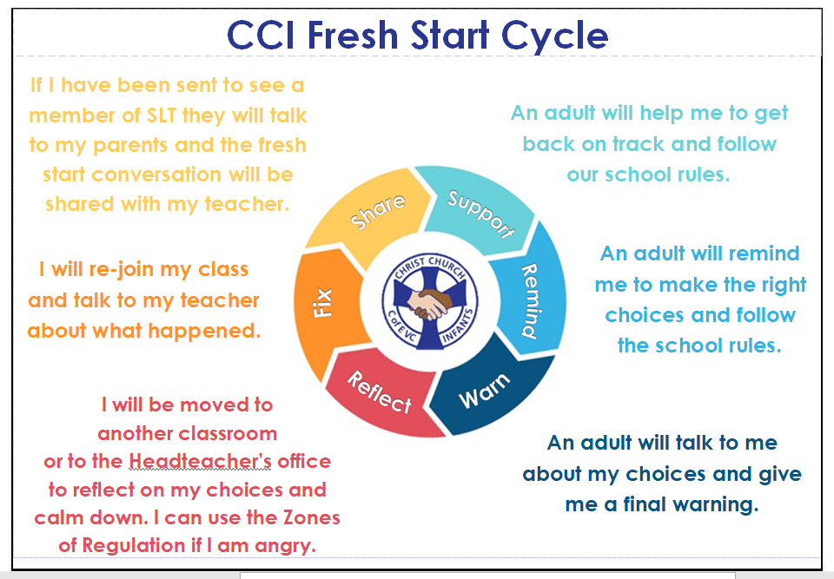

Appendix 2: Script for adults

This is the language used by school adults at the ‘warning’ stage of the fresh start cycle.
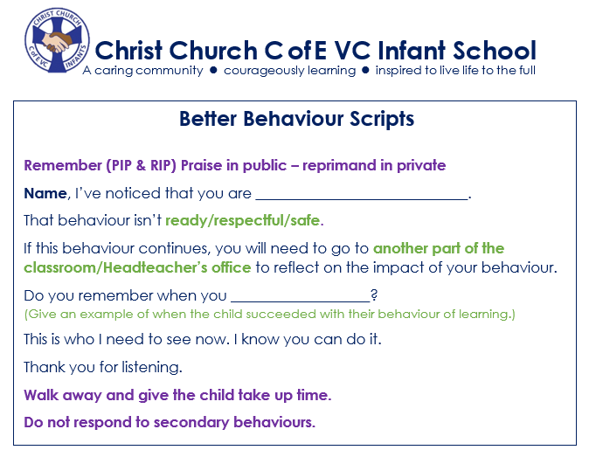

Appendix 3: Fresh start Conversation
A Fresh Start

Which of our school rules did you not follow?
Ready Respectful Safe
What happened?

What were you thinking/feeling at the time?

What impact did your actions have on others?

How could you do things differently next time?

Appendix 4: Lunchtime behaviour plan – ‘wheel of choices’
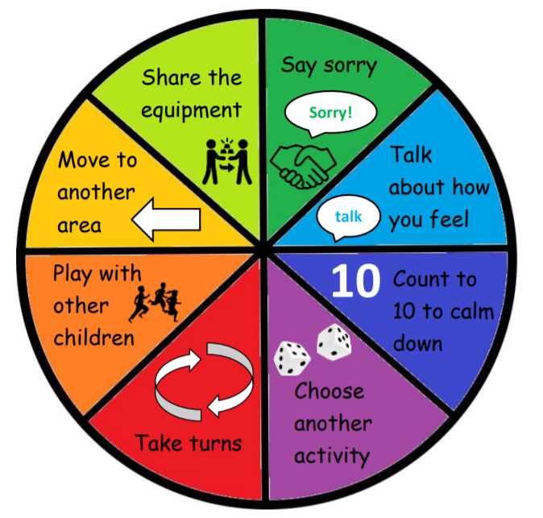
At lunchtimes, children always need to be ready, respectful and safe.

Adults suppport children to be ready, respectful and safe by doing the following;

- Helping us to play with the equipment safely.
- Sharing the choices wheel with us so that we make sensible choices.
- Listening to us when something goes wrong.
- Awarding head teacher awards for and telling our teachers about ‘above and beyond’ behaviour.
- Reminding us about the school rules when needed.

What happens if we aren’t following the rules at lunchtime?
- Remind children about the wheel of choices, show visual.
- Listen and remind. Listen to the child, remind about the school rules, ready, respectful and safe.
- Use the script to remind children of your expectations.
- Send inside to see SLT or ask for SLT support if behaviour continues.
- SLT to have a restorative conversation, following time out.
- SLT may need LBS to have child rejoin play. This is a fresh start and the child must be welcomed back to the play area warmly. They may also prefer to go to the nurture space to relax/play.

Appendix 5: Behaviour Reminder, Warnings and Sanctions


