
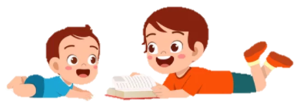
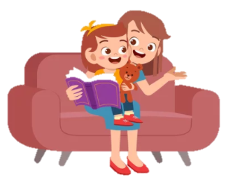

Ask questions & get children thinking:
What might happen next?
Why did that happen?
How are the characters feeling?
Did you like that part?
Which part of the story was your favourite?
Can you think of a different ending?
What would happen if…
Until children get confident with such questions, you may need to model answering for them.
Make reading fun:
Add funny voices.
Include games such as I-spy - Make up a challenge – who can spot the most… can you find… Get creative with the story - The beauty of having a no words in a book is that you can make up anything.
We want children to handle books carefully, to enjoy stories and looking at books. Reading plays a vital role in children’s development.
Once your child starts to learn phonics (sounds that make up words) they will begin to read words in their books. The pink level books will have sounds we have learnt in school. Your child may begin to blend the sounds and repeat the words.
Please share your child’s book with them at least 5 times a week. Write in their reading record when you have read together. We will change books once a week. Reading a book more than once helps children to be familiar with the book and have more confidence when retelling the story. A story each night at bed time is important quality time with your child and helps children’s love of reading develop. Any reading can be recorded in your child’s reading record; all reading is important and valued! Happy reading! The reception team.
Discuss the pictures:
Take your time and look at all of the pictures in the book, turn the pages carefully and talk about each page – give children the language to discuss the stories. There may be pictures of things they don’t know, it is your job to explain the things they see.
If your child is not confident to talk about the story, say your ideas out loud: “I think…” “I like…” “I wonder…”
Talk about what you can see: What is happening? What are the characters doing? How are they feeling?
How do you know?
Make up a story together.
Discuss the features:
Look at the cover – what can you see? What do you think it could be about? Which characters are in this book?
Find the title – the name of the book. Read this to your child. Talk about what the title makes you think
about the book.
Where do you think the story is set?
Is it a story book or an information book?
First reading books are lilac. Lilac books are to help the development of storytelling and an interest in books. There are pictures and some repetitive words. With books, your role is to encourage ‘book talk’ in different ways, with pink books you can look for sounds and try to blend simple words

Make space and time to read together. Turn off the TV and devices, have 5-10 minutes with your story, snuggle up and have special time together.
How to help your child to read their school reading book:

