Round in a loop like an empty hoop makes zero.  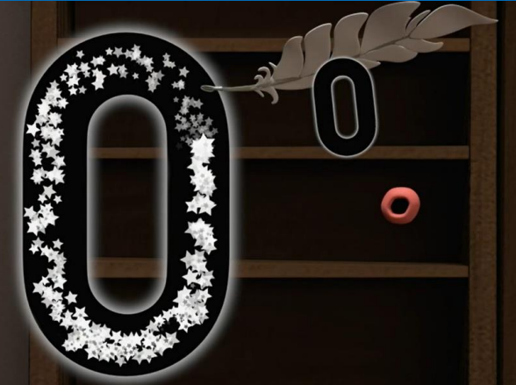 | Down and around then a line up high. High five!  
One line down like a stick, makes a one, that was quick.   | Start with a curve, round with a swish. That’s the way you make a six.  
One curve down is what you do, then straight across to make a two.   | A line in the sky and down to the ground. That’s how lucky seven is found.  
Around the tree around the tree, that’s the way to make a three.   | Make an ‘s’ and do not wait. When it’s joined up you have an eight.  
Down and across then down once more that’s the way to make a four.   | Make a loop then a line. That’s the way to make a nine.  
 Number Formation

