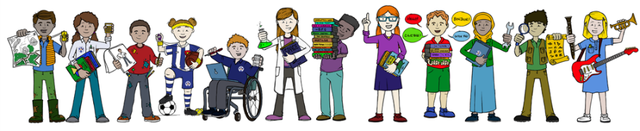
By the end of Term 2, most children in Reception can…
Reading
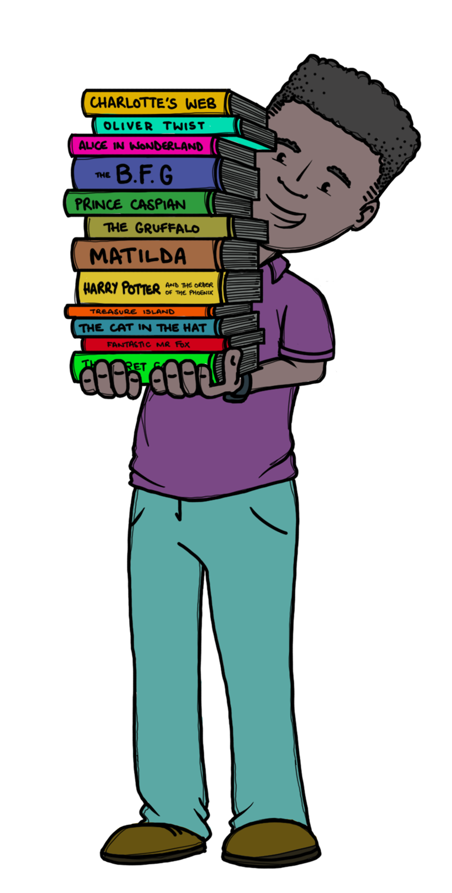 | Comprehension  - Enjoy stories and listen attentively at story time  - Enjoy talking to others about favourite stories  - To talk about the main events in the story and predict what might happen next  - Retell a story using role play or small world resources, using some story language  Word Reading  - Know all Phase 2 sounds  - Blend and read Phase 2 3- letter words eg sun, rat, tip  - Read Phase 2 captions  - Read Phase 2 Tricky Words  - Read set 1 High Frequency words  - Read Phase 2 sounds and Tricky Words in books
Writing
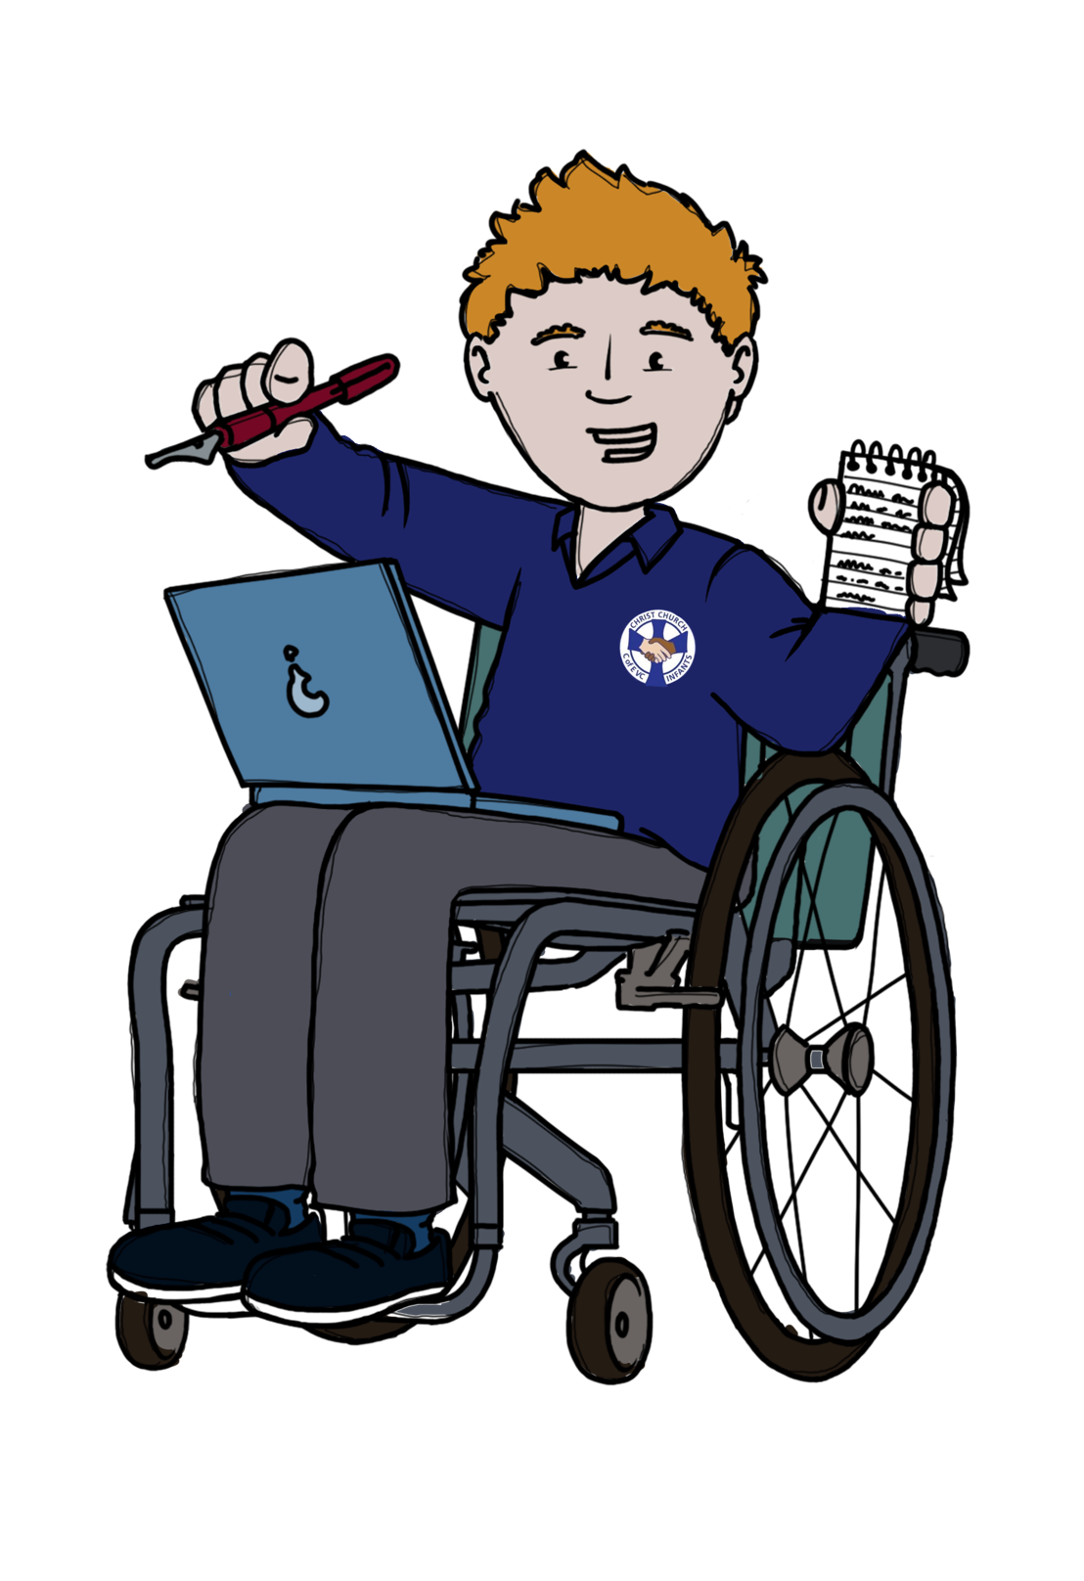 | - Develop fine motor skills so they can use a range of tools competently and safely  - Hears and says initial sounds in words c’ for ‘cat, ‘b’ for banana  - Can segment Phase 2 words. (c-a-t, r-u-n)  - Can write 2/3 letter words  - Attempt to write simple captions  - Say a simple sentence for writing (oral and count words)  - Write some lower case letters correctly.  - Can write their own name  - Can retell a story using some story language to support their writing
Maths
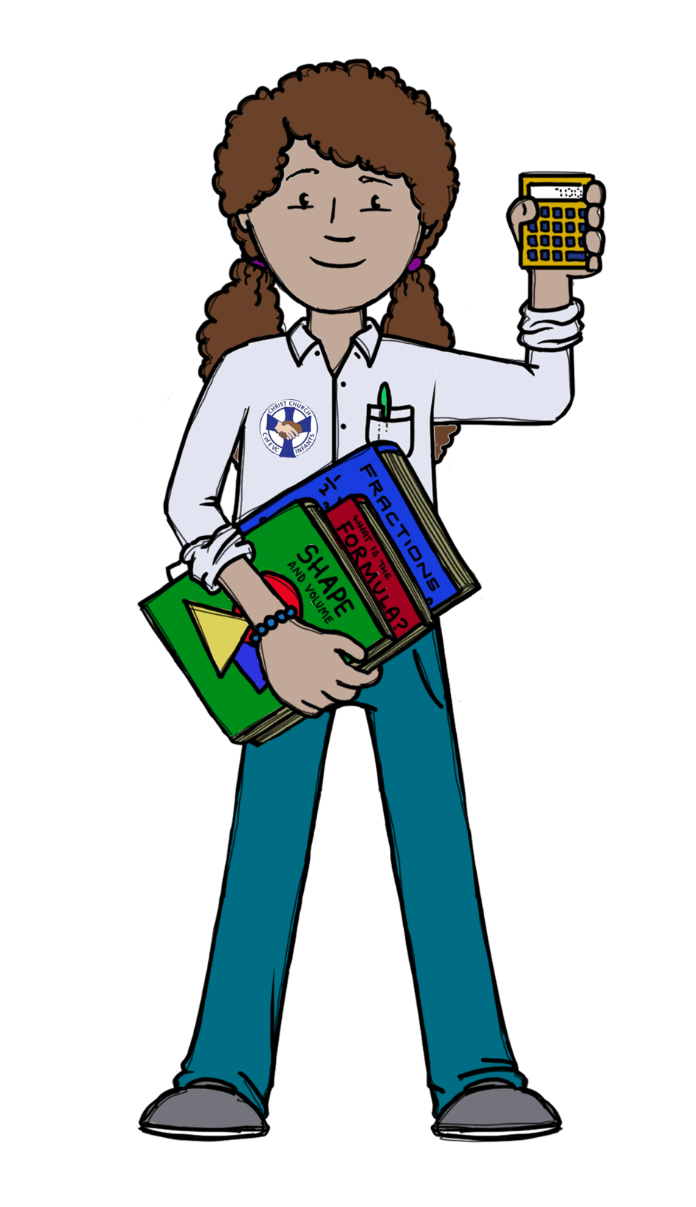 | - Can subitise (to look at an amount and know it’s value without counting each object) to 5 and is beginning to talk about the different ways that amounts of 5 can be made.  - Beginning to verbally count beyond 5  - Count objects accurately to 5 using one to one correspondence (cardinality) and can identify when objects have the same, less than or more than.  - Know that numbers are made up of other numbers e.g 2 and 3, 4 and 1 make 5  - Represent up to five using their fingers.  - Order numbers up to five  - Read numerals to five and match to an amount  - Create a repeated pattern

